CST 2309 Midterm Project – MAXIMO ANTIGUA

COMPLETE THE 14 SECTIONS

1. What is Responsive Web Design? How did you implement Responsive Web Design Principles in your Final Project?

Responsive Web Design is when a website displays the same content differently based on the device that is being used/the pixels available on the screen. I implemented Responsive Web Design Principles in my final project by changing the size of images as the screens get smaller (1000px, 800px, 620px), some text gets smaller, and other information was reorganized. Some of them are the footer, the nav and some minor flex containers.

1. Add the Netlify link for the deployed Website

https://elconuco.netlify.app/

1. Add a screenshot of the **wireframe for page 1: About US**

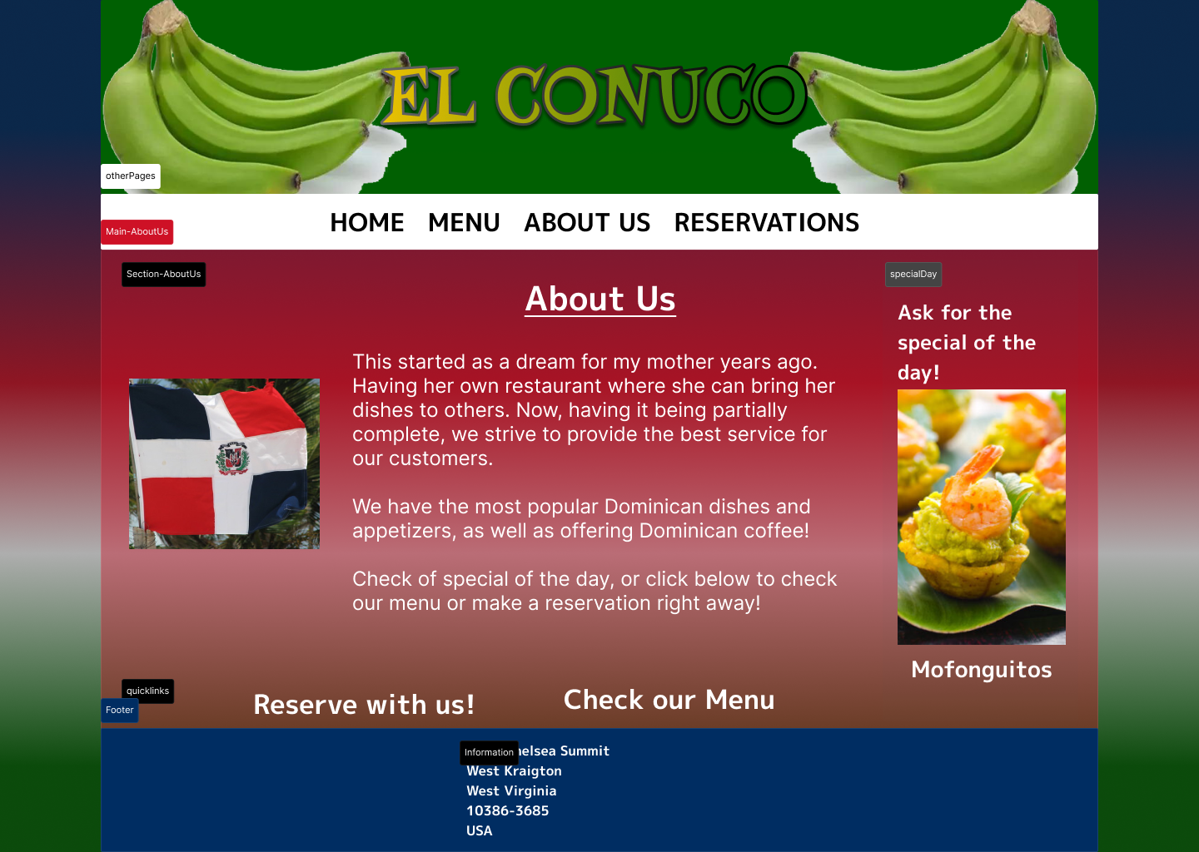

* Made before, to give me an idea. Final product changed drastically.

1. Add a screenshot of About Us page displayed in a browser

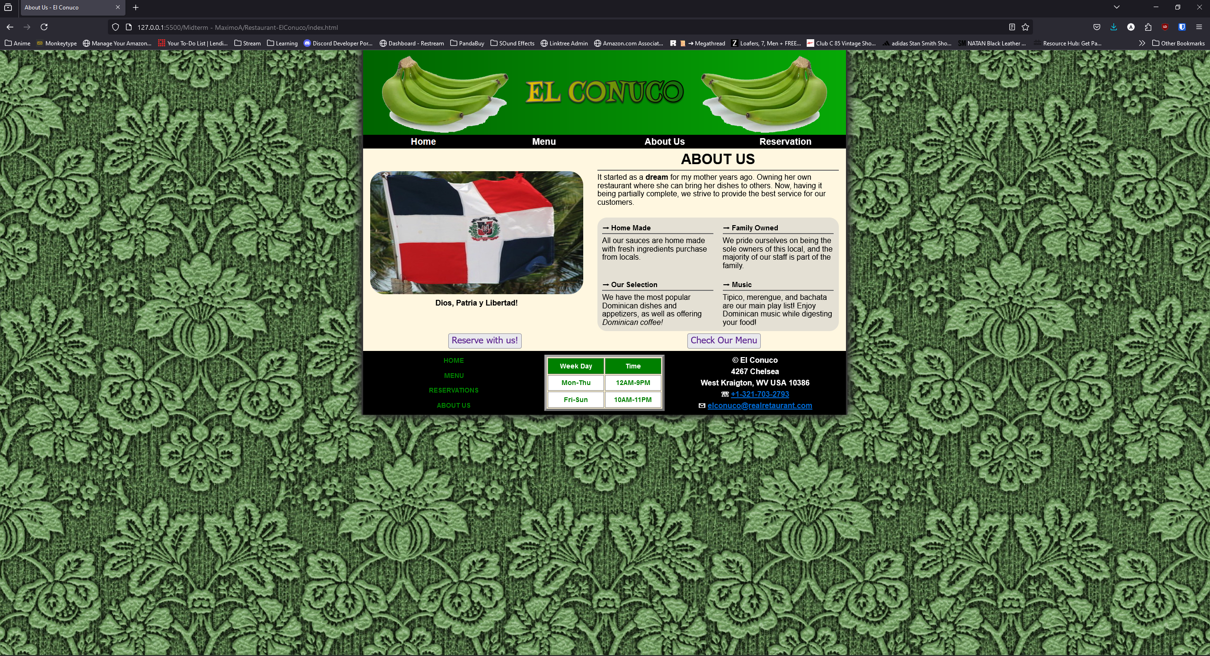

1. Add a screenshot the **About US page HTML validated Report** using W3C MarkUp Validation Services

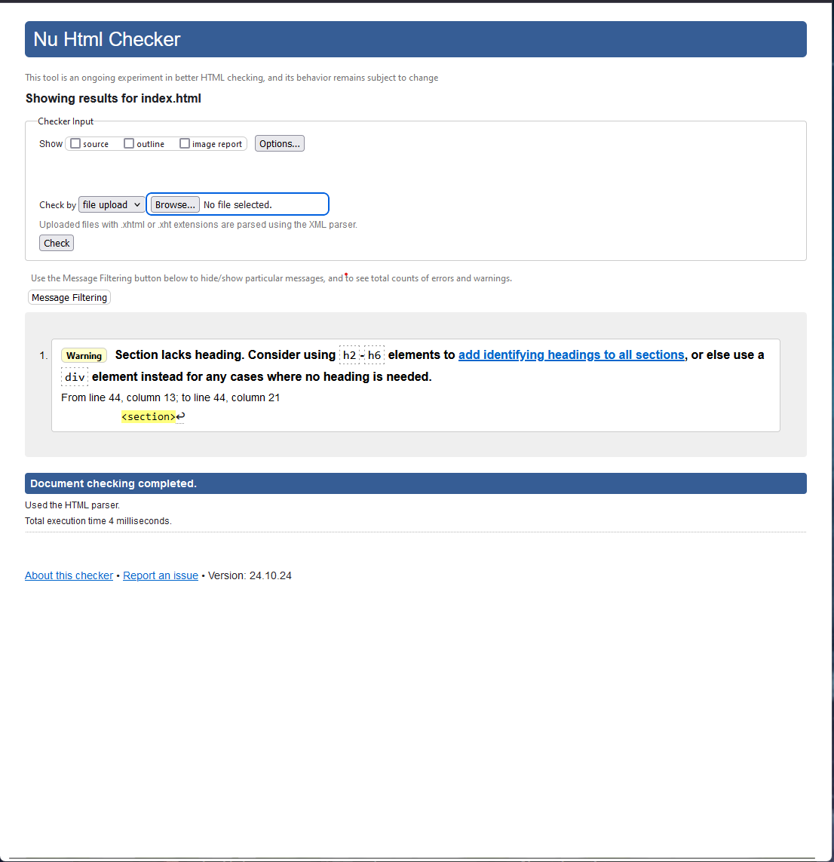

1. Add a screenshot the **About US page CSS3 validated Report** using W3C MarkUp Validation Services

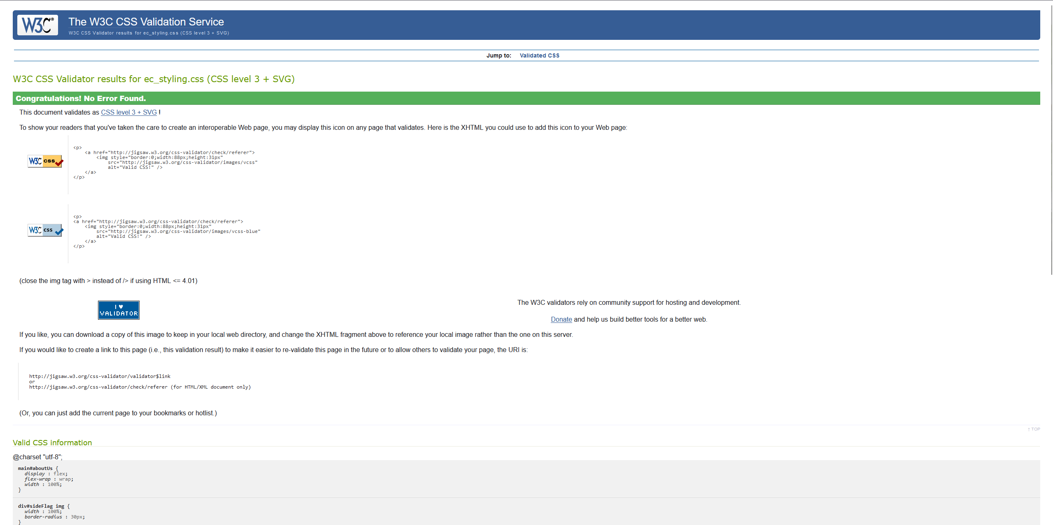

1. Add a screenshot of the wireframe for page 2: Menu

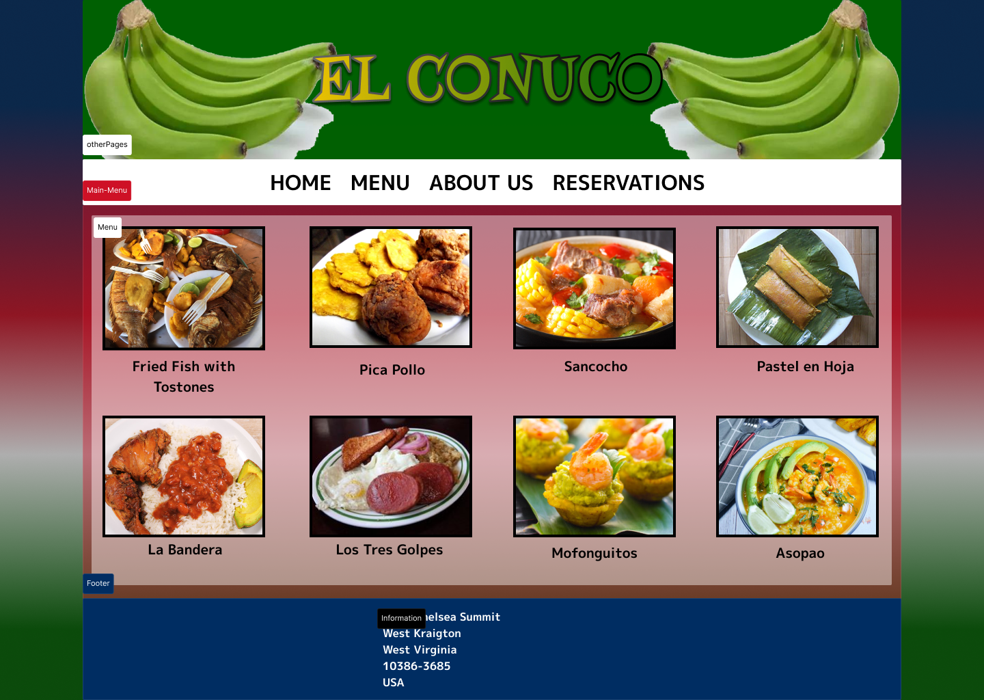

* Made before, to give me an idea. Final product changed drastically.

1. Add a screenshot of Menu page displayed in a browser

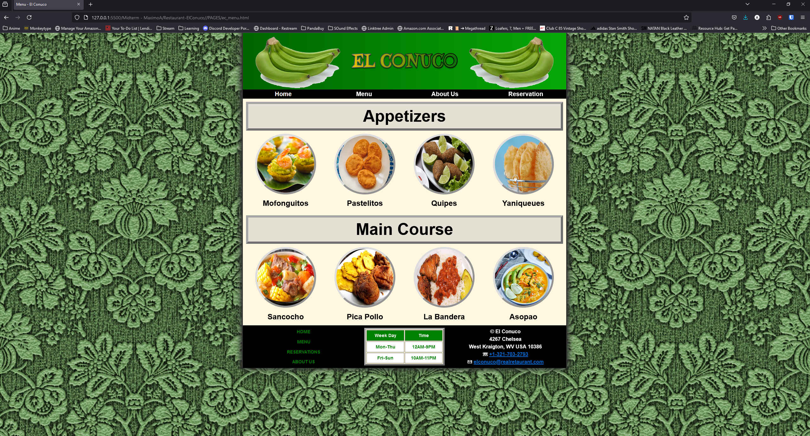

1. Add a screenshot the validated **Menu page HTML5 validated Report** using W3C MarkUp Validation Services

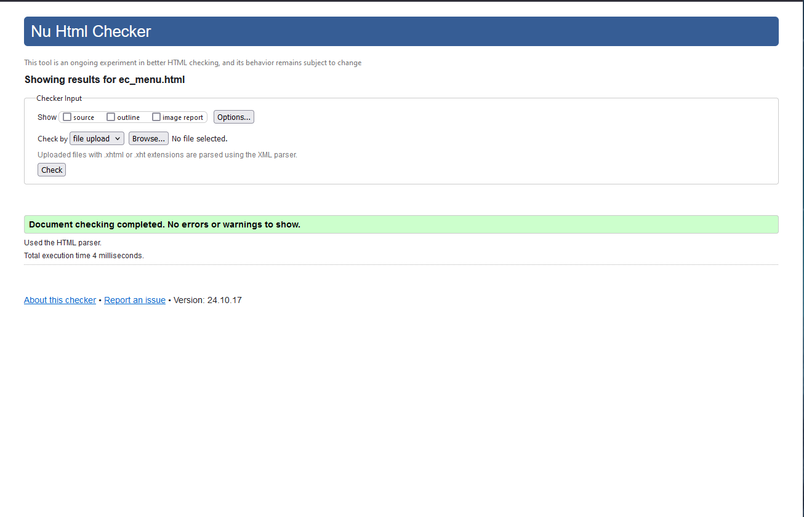

1. Add a screenshot the validated **Menu page CSS3 validated Report** using W3C MarkUp Validation Services

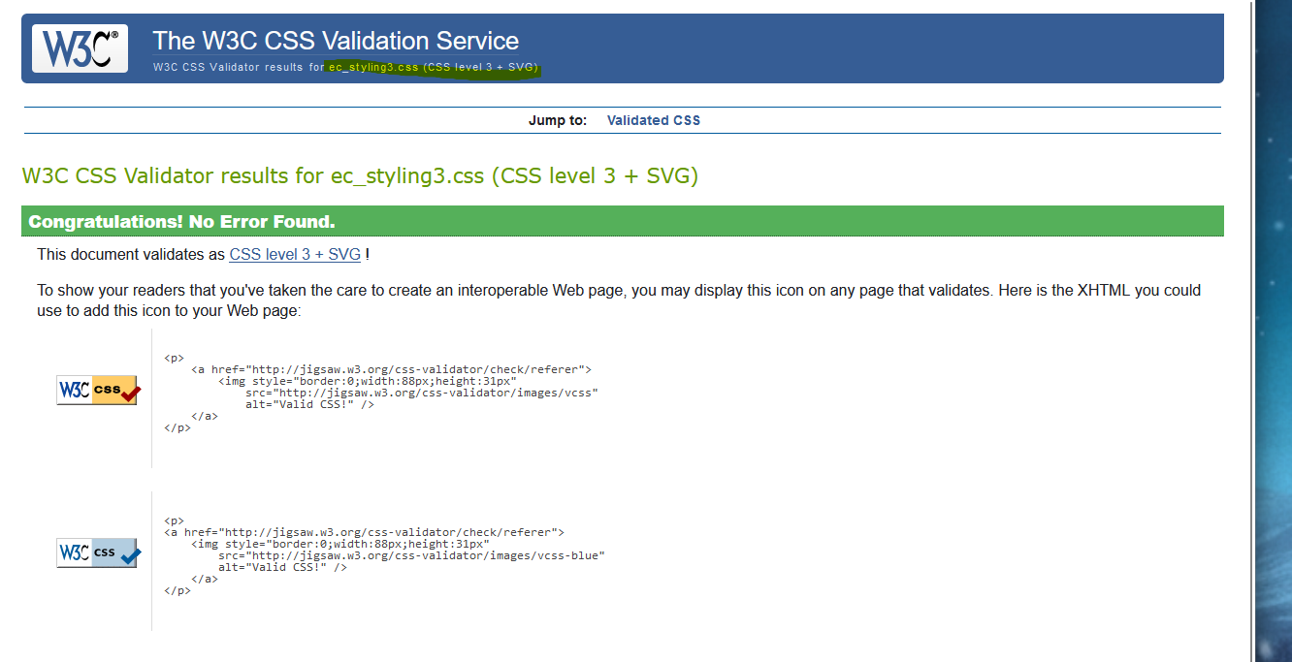

1. Add a screenshot of the wireframe for page 3: Reservation

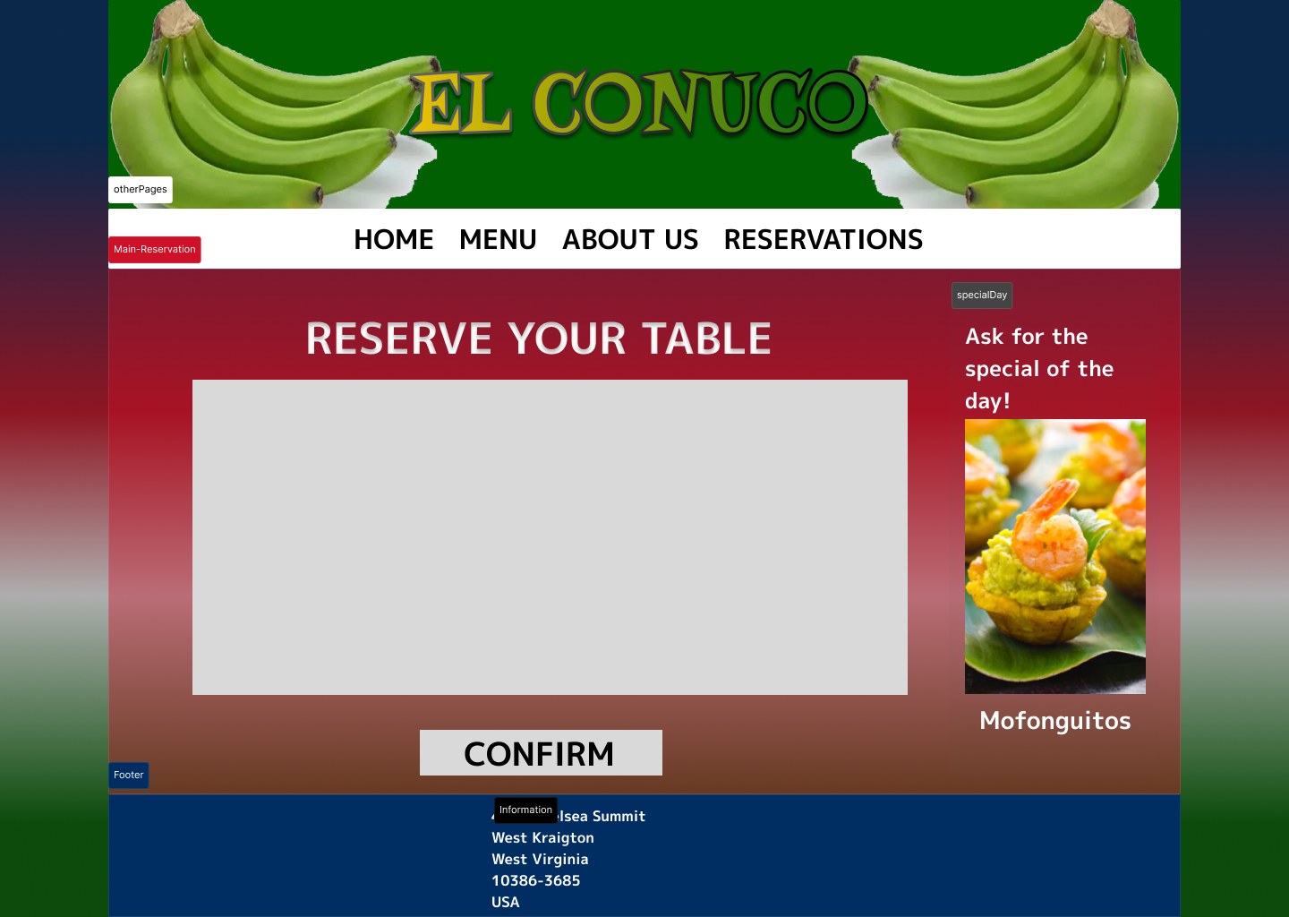

* Made before, to give me an idea. Final product changed drastically.

1. Add a screenshot of Reservation page displayed in a browser

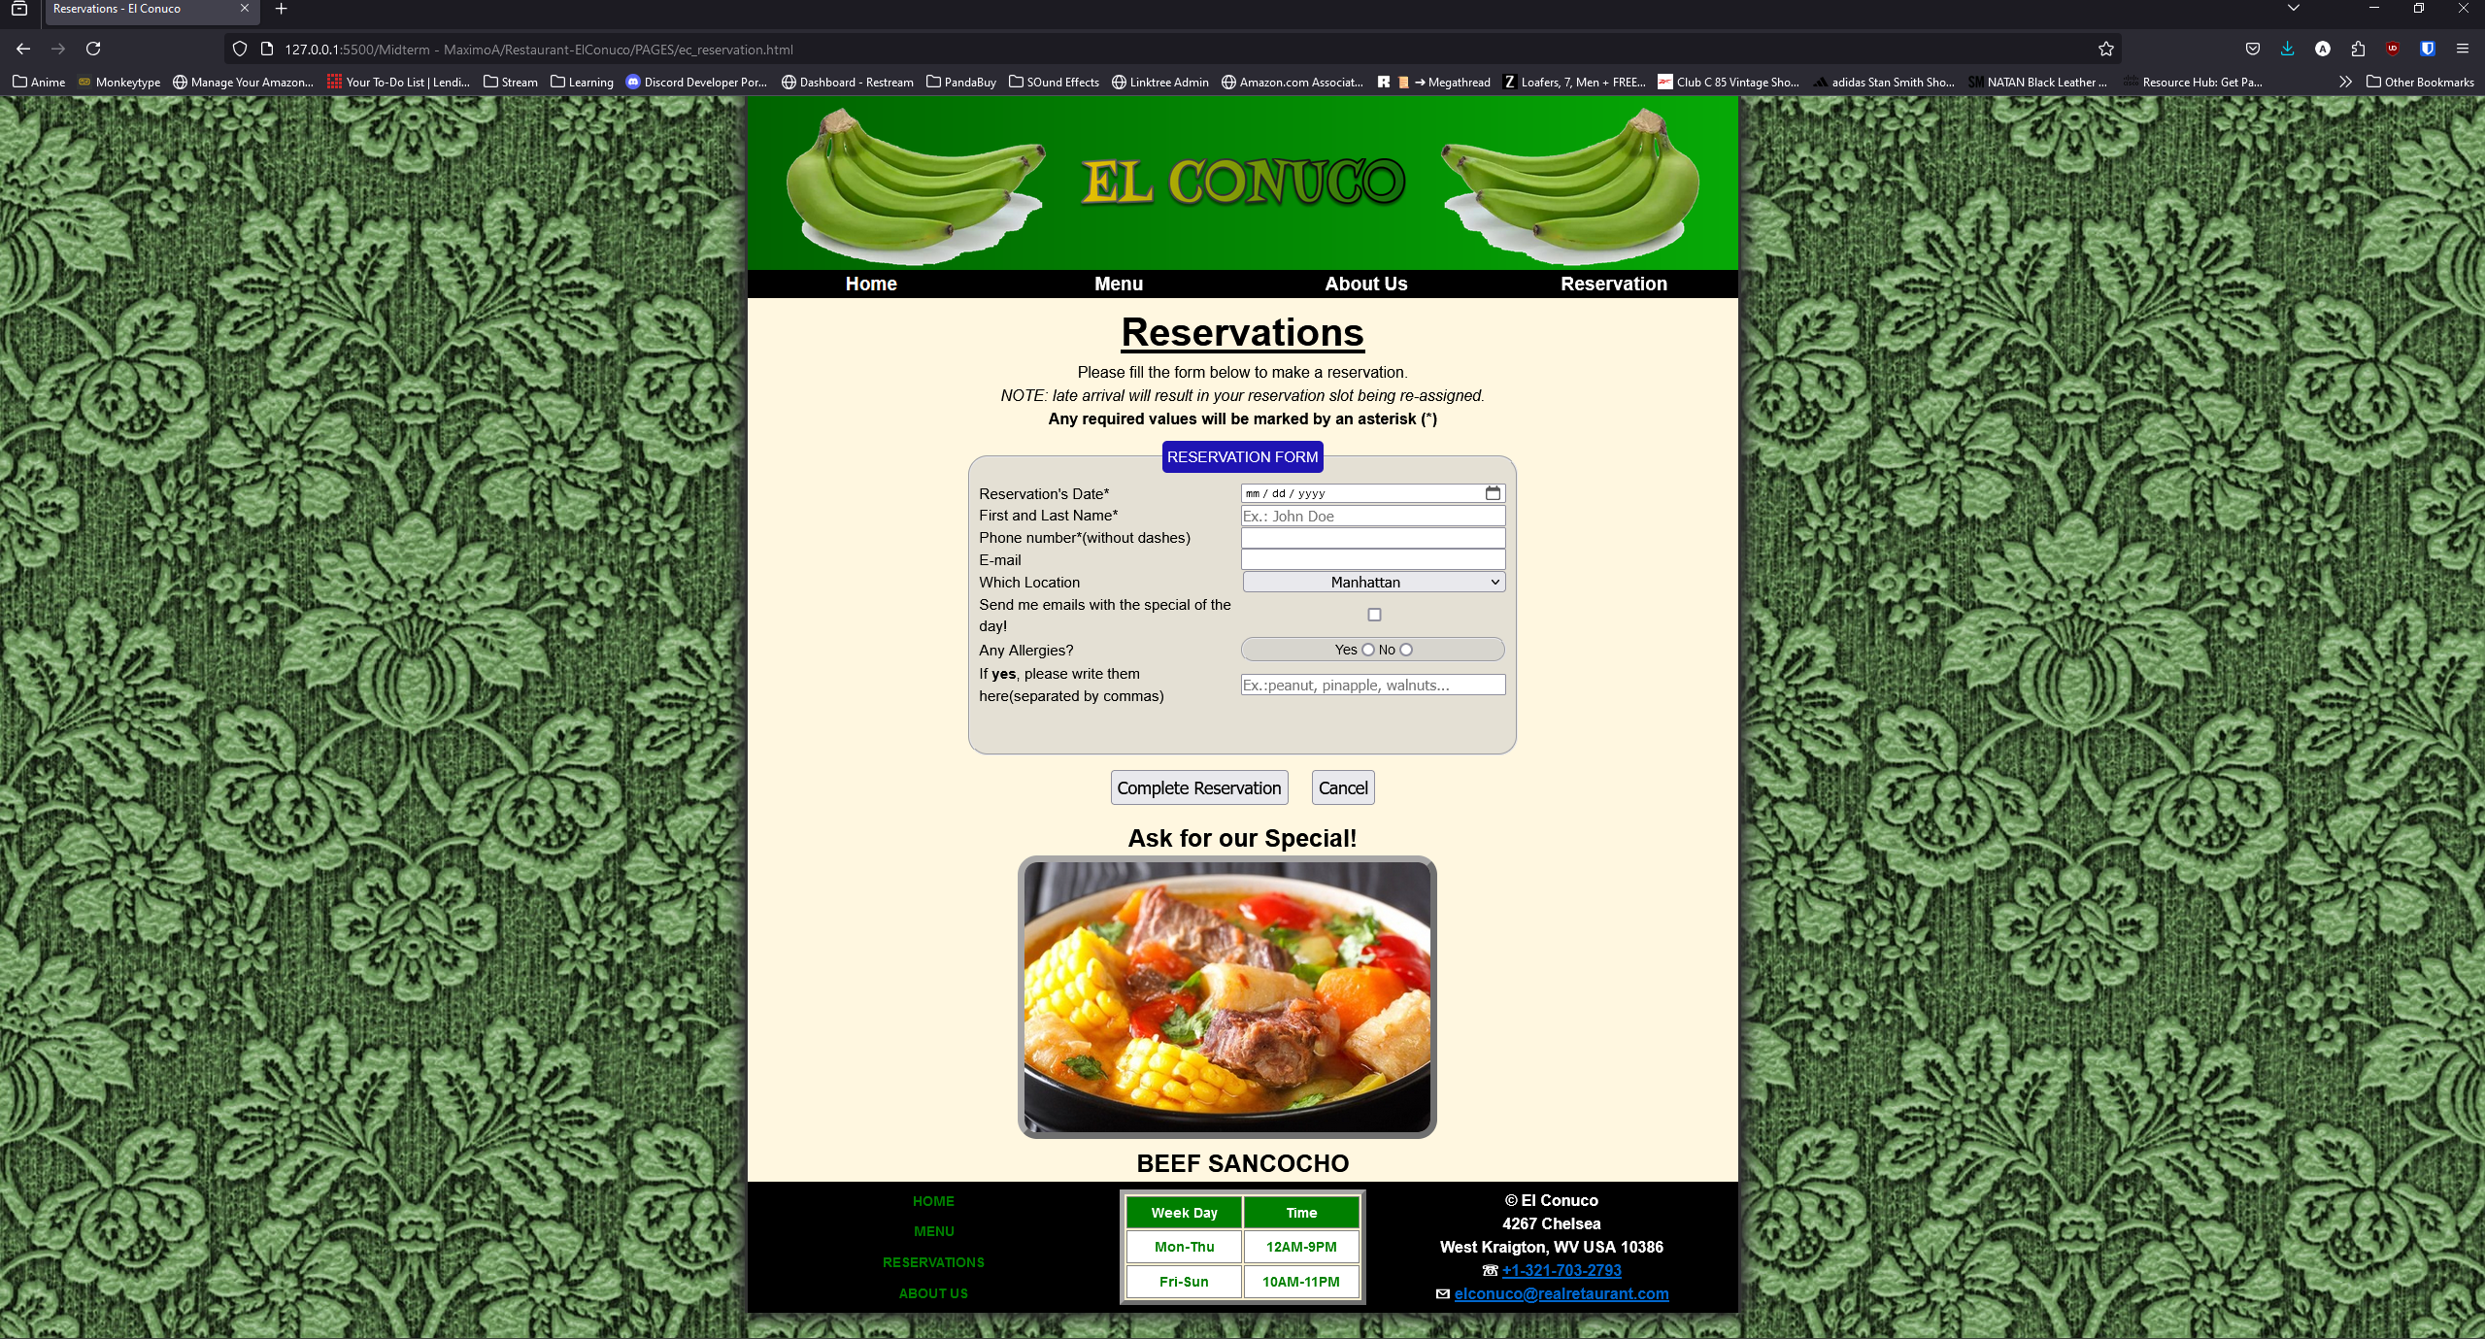

1. Add a screenshot of the validated **Reservation page HTML5 validated Report** using W3C MarkUp Validation Services

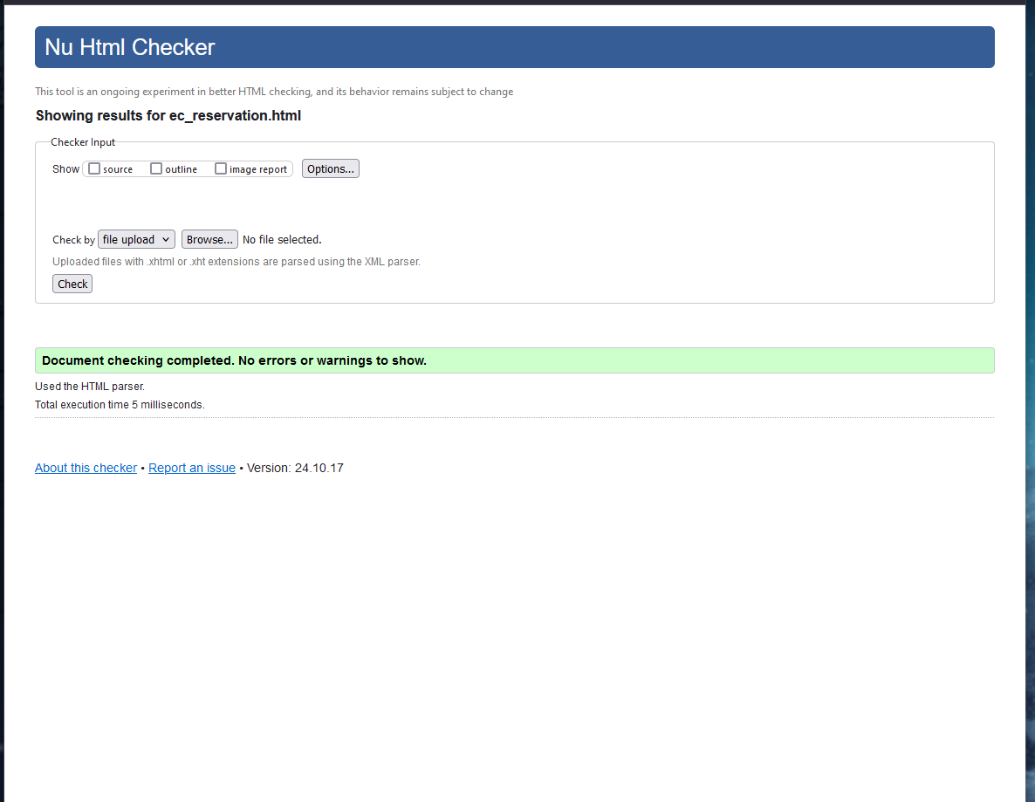

1. Add a screenshot of the validated **Reservation page CSS3 validated Report** using W3C MarkUp Validation Services

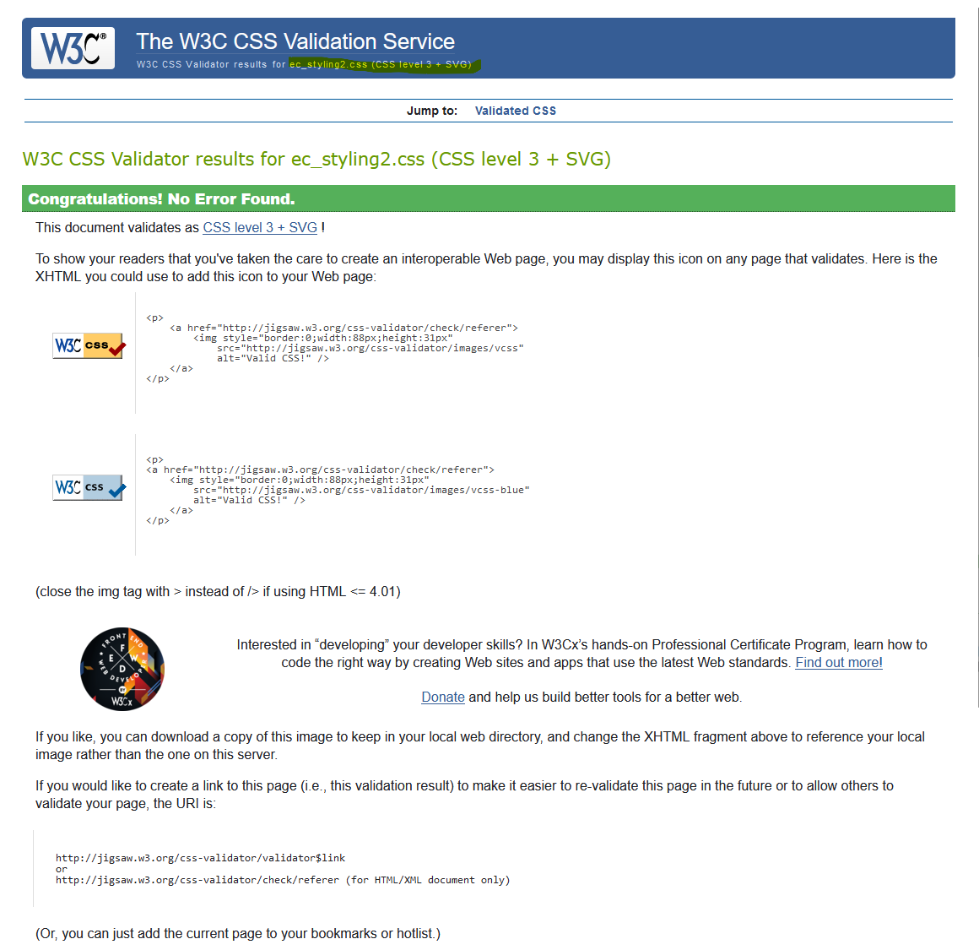

Adding my other two .CSS used:

Ec_base.css and ec_tables.css

15.

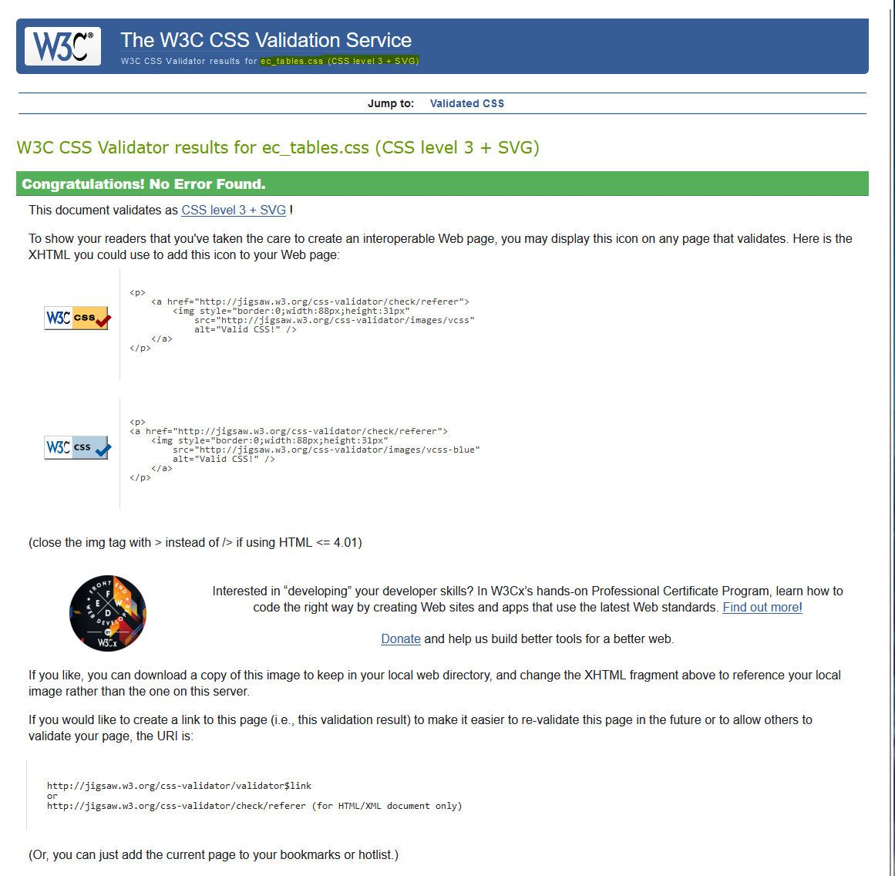

16.

